Poster Presentation Guidelines

(adapted from a Handout developed by Dr. Claire Wolan-O’Connor)

Posters should be in the format of those presented at psychological conferences such as that of the American Psychological Association. Posters do not need to be professionally printed, laminated, or processed in any expensive manner. They should, however, look “good.”

Your Research

Your article should be interesting and relevant to your audience. Where applicable, you are to present the relevant sections of methods, results, etc.

Presentation

You should be prepared to discuss why you chose to do the research, how the experiment was conducted, the significance of the findings, and be able to answer questions from other students. To be fully prepared to discuss the topic, you may need to read other articles relevant to the research, perhaps ones mentioned in your background research. In a typical conference poster section, there are no formal presentations. However, you should be prepared to discuss your work at any time as conference attendees stroll through the poster areas. Some may want to read your poster silently, some will ask you to talk about it, others may have very detailed questions.

Handouts

At least one handout is suggested. It should give the reader information about your research as well as your name. In a conference setting, handouts may be the full paper that the poster is based upon or one that briefly describes the research.

Poster Guidelines

Your poster should be 3.5 to 4 feet high by 5.5 to 6 feet wide. You may create this size in any way you wish (e.g. tape together poster boards, butcher paper in a size such as that used on bulletin boards, etc.). Some of you may be able to have custom posters printed. These are created in PowerPoint. Ask your professor about this. You may tape your poster to a provided board while presenting or it may be freestanding. Typically, conference posters are tacked to large bulletin boards and authors stand next to them awaiting visitors.

Poster Sections

1. Title

Titles vary but are typically 12 to 15 words. Include all of the authors associated with the research project. Format should be first and last names. Include the institutions (and departments) with which the authors are associated. The lettering for the title section should not be less than 1 inch high. All other lettering should be at least 3/8 inches high, preferably in a bold font.

1. Abstract

Use the paper’s abstract. You may want to edit it for length. Be sure that it includes the hypothesis, the variables that were studied, how they were studied, and the findings. This section should be no more than 150 words.

1. Introduction

Note the important previous research findings that led to this research.

1. Methods

Include the basics of the research design so that your audience will understand what the research entailed and how it was conducted. Include the participant demographics and tests used.

1. Data/Results

This is where tables, charts, and graphics are nice to have. You may want to copy ones from the article or try to make some of your own. Label and briefly describe all graphics. Color is great to have here if possible.

1. Conclusions

Be concise and clear. Highlight the findings of the research and its importance. Include directions for future research if known.

1. References

Use a few of the major references from the paper. Definitely include any that you mentioned in the introduction section. You do not have to list ALL of the references from the paper.

Recommendations

* Be clear and concise in the material you print for your poster.
* Use large font to ensure that your audience can read it from a distance of about 3 feet away.
* Use color when possible.
* Use graphics. (You want your poster to be one that people like and remember and people like pictures!)
* Be sure to provide clear labels for each section of your presentation.

Sample Poster Arrangements

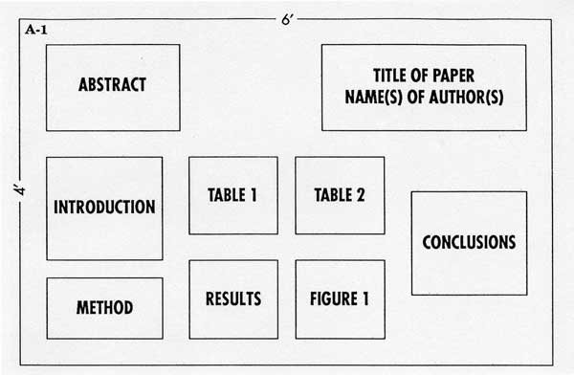

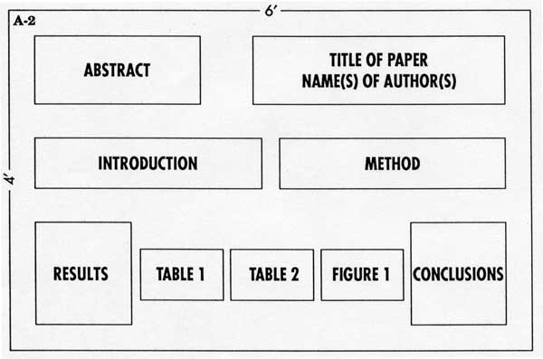

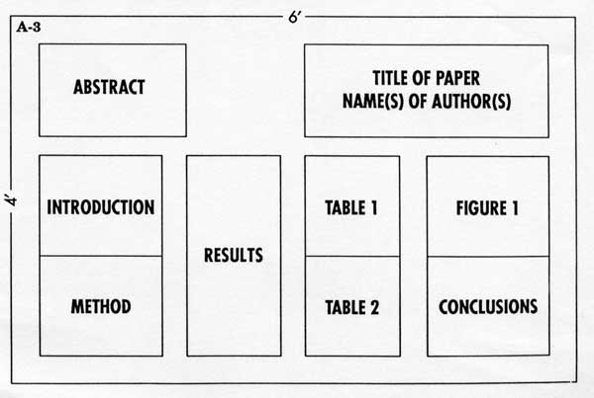

**TITLE OF PAPER**

**AUTHOR(S)**

Abstract

Introduction

Graphic

Graphic

Conclusions

References

Methods